book

Universidade de Brasília - UnB
Departamento de Engenharia Eletrica - ENE

Pré-relatório Experimento 4
Implementação de circuitos combinacionais com multiplexadores

Carlos Eduardo Taborda Lottermann
180041509

Prof. Luís Fernando Ramos Molinaro

Brasília, DF
2019
Desenhos esquemáticos:
Visto 1:
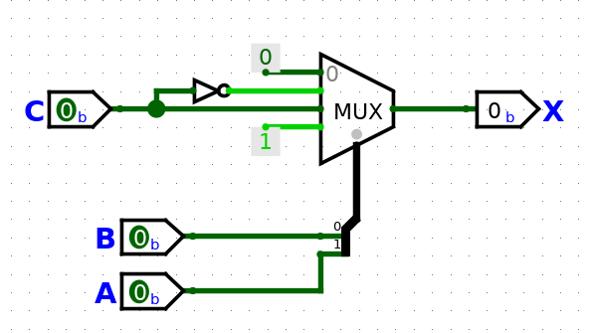
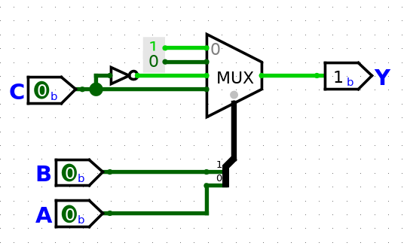
Visto 2:
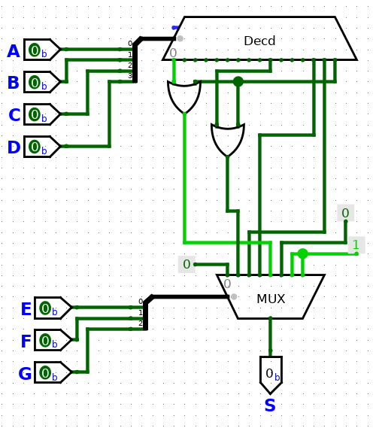
Código em VHDL do 1º visto:
library IEEE;
use IEEE.STD_LOGIC_1164.ALL;

entity Visto_1 is
Port ( A : in STD_LOGIC;
B : in STD_LOGIC;
C : in STD_LOGIC;
X : out STD_LOGIC;
Y : out STD_LOGIC);
end Visto_1;

architecture Visto_1_op of Visto_1 is

component MUX is
Port ( S : in STD_LOGIC_VECTOR (1 downto 0);
D : in STD_LOGIC_VECTOR (3 downto 0);
Y : out STD_LOGIC);
end component;

signal X_sel : STD_LOGIC_VECTOR (1 downto 0);
signal X_in : STD_LOGIC_VECTOR (3 downto 0);
signal Y_sel : STD_LOGIC_VECTOR (1 downto 0);
signal Y_in : STD_LOGIC_VECTOR (3 downto 0);

begin

X_sel(0) <= B;
X_sel(1) <= A;

X_in(0) <= '0';
X_in(1) <= not C;
X_in(2) <= C;
X_in(3) <= '1';
Xu: MUX port map(X_sel,X_in, X);

Y_sel(0) <= B;
Y_sel(1) <= A;

Y_in(0) <= '1';
Y_in(1) <= '0';
Y_in(2) <= not C;
Y_in(3) <= C;

Yu: MUX port map(Y_sel,Y_in,Y);

end Visto_1_op;

Arquivo UCF do 1º visto:
NET "A" LOC = "K3";
NET "B" LOC = "L3";
NET "C" LOC = "P11";
NET "X" LOC = "M11";
NET "Y" LOC = "M5";

Código VHDL do 2º visto:
library IEEE;
use IEEE.STD_LOGIC_1164.ALL;

entity Visto_2 is
Port ( A : in STD_LOGIC;
B : in STD_LOGIC;
C : in STD_LOGIC;
D : in STD_LOGIC;
E : in STD_LOGIC;
F : in STD_LOGIC;
G : in STD_LOGIC;
S : out STD_LOGIC);
end Visto_2;

architecture Visto_2_op of Visto_2 is

component MUX_8 is
Port ( S : in STD_LOGIC_VECTOR (2 downto 0);
D : in STD_LOGIC_VECTOR (7 downto 0);
Y : out STD_LOGIC);
end component;

component Decoder is
Port ( A : in STD_LOGIC_VECTOR (3 downto 0);
Y : out STD_LOGIC_VECTOR (15 downto 0));
end component;

signal Decoder_sel : STD_LOGIC_VECTOR (3 downto 0);
signal Decoder_out : STD_LOGIC_VECTOR (15 downto 0);

signal MUX_sel : STD_LOGIC_VECTOR (2 downto 0);
signal MUX_in : STD_LOGIC_VECTOR (7 downto 0);
signal MUX_out : STD_LOGIC;

begin

Decoder_sel(0) <= A;
Decoder_sel(1) <= B;
Decoder_sel(2) <= C;
Decoder_sel(3) <= D;

Dec: Decoder port map(Decoder_sel,Decoder_out);

MUX_sel(0) <= E;
MUX_sel(1) <= F;
MUX_sel(2) <= G;

MUX_in(0) <= '0';
MUX_in(1) <= Decoder_out(9) or Decoder_out(15);
MUX_in(2) <= Decoder_out(14);
MUX_in(3) <= Decoder_out(13);
MUX_in(4) <= Decoder_out(1) or Decoder_out(15);
MUX_in(5) <= '0';
MUX_in(6) <= '1';
MUX_in(7) <= '1';

M: MUX_8 port map(MUX_sel,MUX_in,S);

end Visto_2_op;
Arquivo UCF do 2º visto:
NET "A" LOC = "F3";
NET "B" LOC = "G3";
NET "C" LOC = "B4";
NET "E" LOC = "K3";
NET "F" LOC = "L3";
NET "G" LOC = "P11";

NET "S" LOC = "M5";

